Ideation Phase

Brainstorm & Idea Prioritization Template

|  |  |
| --- | --- |
| Date | 29 April 2023 |
| Team ID | NM2023TMID09009 |
| Project Name | Drowsiness Detection and Alerting System |
| Maximum Marks | 4 Marks |

**Drowsiness Detection and Alerting System**

Feeling abnormally sleepy or tired during the day is commonly known as drowsiness. Drowsiness may lead to additional symptoms, such as forgetfulness or falling asleep at inappropriate times. This is a natural phenomenon in the human body that causes distraction and affects the lives of road users.

According to the National Sleep Foundation, in 2005, 60% of drivers committed drowsy driving in the previous year , and an estimated of 6,400 people died annually in crashes involving drowsy driving

The above alarming statistics have shown the necessity to implement a system for driver drowsiness monitoring and alerting, thereby preventing unfortunate traffic accidents from happening

# Step-1: Team Gathering, Collaboration and Select the Problem Statement

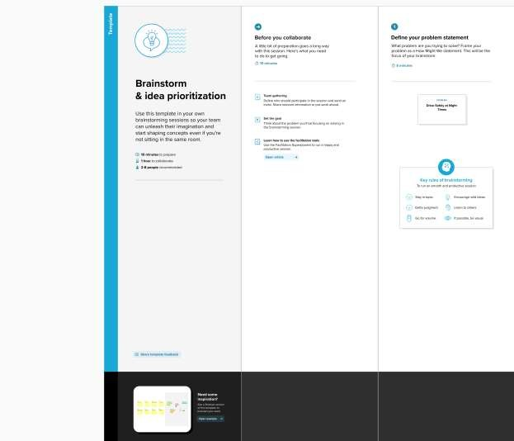

**Step-2: Brainstorm, Idea Listing and Grouping**

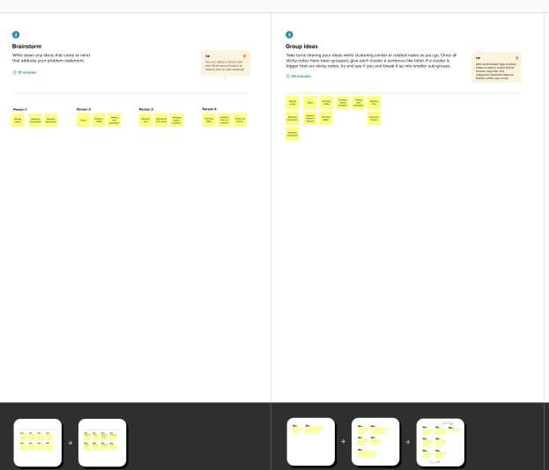

# Step-3: Idea Prioritization

